**Review Worksheet Answers – Fluid Homeostasis**

1: Define the following terms:

(3 marks)

Intracellular fluid: *The fluid within the cells – mostly in the cytoplasm*

Intercellular (Interstitial) fluid: *The fluid surrounding the cells*

Plasma: *The fluid component of the blood, in the blood vessels*

2: If the intracellular fluid has greater solute concentration than the intercellular fluid, what fluid transfer will occur?*

(4 marks)

*The intracellular fluid will have a lower water concentration (1) compared to the intercellular fluid (1), so fluid will move into the cells (1) via osmosis (1).*

3: List three main ways that water is gained by the body and three main ways that water is lost.

(3 marks)

|  |  |
| --- | --- |
| Fluid Gain | Fluid Loss |
| *Drink* | *Kidney* |
| *Food* | *Skin* |
| *Metabolic water* | *Lungs* |

4: Where does metabolic water come from?*

(4 marks)

*Metabolic water is a by-product of cellular respiration (1) which uses glucose and oxygen to produce ATP (1), with by-products of water (1) and carbon dioxide (1)*

5: Where in the nephron does ACTIVE reabsorption of water occur?

(1 mark)

*In the distal convoluted tubule (0.5) and collecting duct. (0.5)*

6: Which hormone is involved in regulating active reabsorption of water?

(1 mark)

*Anti Diuretic Hormone (ADH)*

6: Where in the nephron does reabsorption of sodium ions occur?

(1 mark)

*In the distal convoluted tubule (0.5) and collecting duct (0.5)*

7: Which hormone is involved in regulating reabsorption of sodium ions?

(1 mark)

*Aldosterone*

8: How does the Na+ move from the tubules to the blood during this process?

(1 mark)

*Using the Na+/K+ pump*

9: What happens to water as the Na+ is reabsorbed?

*It moves via osmosis (0.5) along with the Na+.(0.5)*

10: What happens to osmotic pressure of the blood as water concentration decreases?

(2 marks)

*Osmotic pressure increases (1) as there is a greater concentration of solutes (1) due to the lesser amount of water.*

11: How is osmotic pressure of the blood detected?

(2 marks)

*By osmoreceptors (1) in the hypothalamus (1)*

12: Draw an annotated homeostatic feedback loop to show what occurs when osmotic pressure increases.

(15 marks out of 18 possible marks on key)

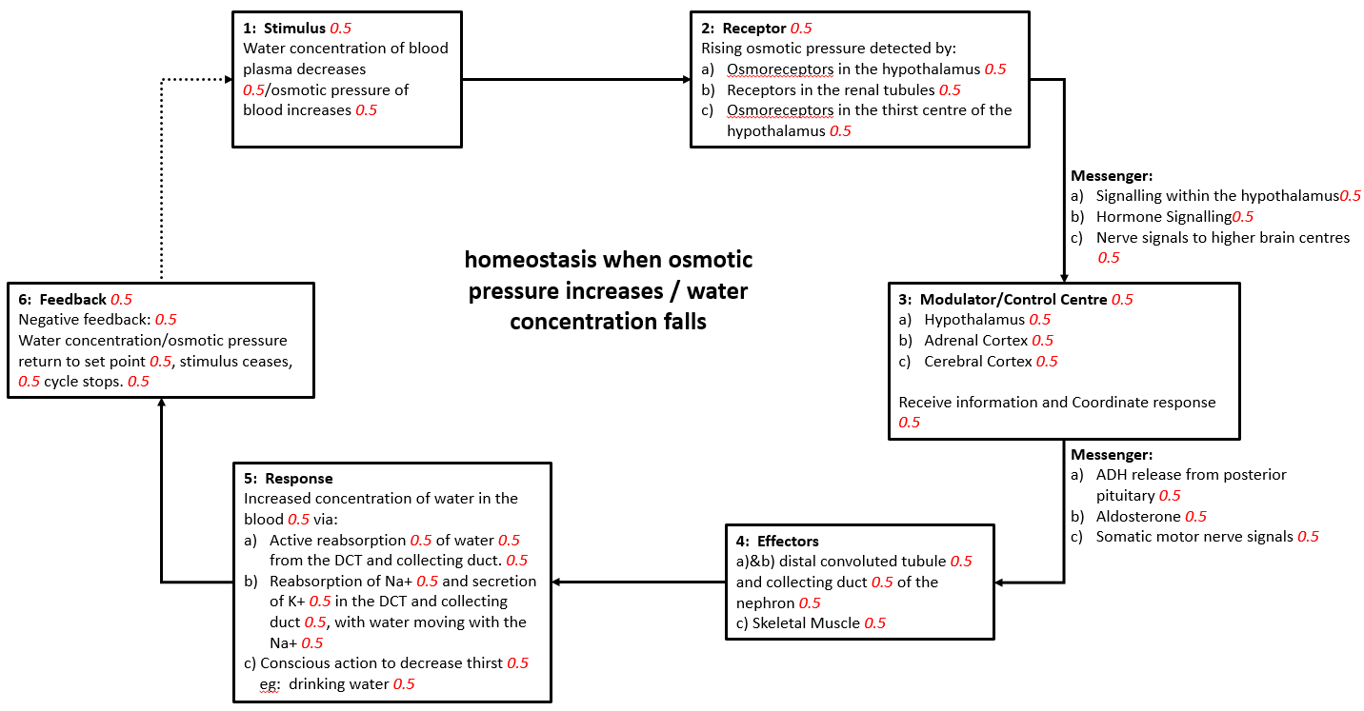

13: Discuss the response of the body when osmotic pressure decreases?

(4 marks)

*Decreases in osmotic pressure are detected by the hypothalamus (0.5) and the renal tubules (0.5), resulting in the inhibition (0.5) of the thirst reflex (0.5), ADH (0.5) and aldosterone excretion (0.5). This allows excess water (0.5) to be excreted by the kidneys (0.5) to maintain homeostatic body fluid composition (0.5)*

14: Genna, Zainab and Yan are all marathon runners. Whilst running a marathon on a warm day Genna does not drink enough water, Yan drinks a large amount of water, and Zainab drinks a large amount of a sports drink with electrolytes. Genna and Yan both collapse and are taken to hospital, and Zainab successfully finishes the marathon.

Using your understandings of body fluid homeostasis, describe in detail why Genna and Yan collapsed but Zainab was successful in completing the marathon.

(25 marks)

*Genna did not drink enough water (1) and was sweating (1) due to prolonged physical exertion on a warm day (1), so she is likely to be suffering from extreme dehydration (1). Symptoms of dehydration include low blood pressure (1) and collapse (1), so this is probably why Genna collapsed and was taken to hospital.   
  
Yan drank enough water (1), but was losing electrolytes such as Na+ (1) through her sweat (1). As a result, the water concentration of her blood rose (1), but her blood Na+ levels were decreasing (1). This meant that there was a higher level of intracellular Na+ (1) than in the blood and extracellular fluid (1), so water moved via osmosis into the cells (1), causing swelling of the brain tissue (1), leading to unconsciousness (1).*

*This condition is known as water intoxication (1) or hyponatremia (1).*

*Zainab also drank a large amount of water (1) to replace what was lost in sweat (1), but also replaced the Na+ lost in sweat (1) due to the electrolytes in the sports drink (1). As a result she was able to maintain body fluid composition (1) within homeostatic tolerance limits (1) and was able to complete the marathon successfully. (1)*

15: In addition to aldosterone, the adrenal cortex also produces cortisol. Describe how the production of cortisol occurs in the body*

(10 marks)

*High levels of stress (0.5) and/or low blood glucose (0.5) stimulate the hypothalamus (0.5) to produce CRF (Corticotropin Releasing Factor) (0.5) which travels in the blood vessels (0.5) of the infundibulum (0.5) to the anterior pituitary (0.5). The anterior pituitary is stimulated to produce ACTH (Adrenocorticotrophic Hormone) (0.5) which travels in the systemic circulation (0.5) to the Adrenal Cortex (0.5). The adrenal cortex is stimulated to produce cortisol (0.5) which travels in the systemic circulation (0.5) to body cells (0.5), stimulating increased breakdown of fat (0.5) and protein (0.5), increased blood glucose (0.5) and anti-inflammatory effects (0.5). Rising cortisol levels have a negative feedback effect (0.5) on the hypothalamus (0.5) and anterior pituitary (0.5) so that further release of cortisol is inhibited (0.5)*